APES

Class 3

Lesson Plan

Bell Ringer: Do you think it is possible for the world to sustain its present population of 6.9 billion indefinitely? Why or why not?

Discuss answers.

Ans: The current global ecological footprint of each person is about 2.7 hectares (6.7 acres), which means humans have overshot our allotment. We can see the short-term results around us—forest destruction, degradation of croplands, loss of biological diversity, declining ocean fisheries, and local water shortages. The long-term outlook, if we do not seriously address our consumption of natural resources, is potentially disastrous. Therefore, it is not likely that we can maintain 6 billion people indefinitely.

Raisin snack activity.

Use Ipads to read

Read Tragedy of the Commons

Teacher check chapter 1 review questions while students read.

Go outside and discuss answers to chapter review questions and tragedy of the commons essay.

Exit Bell Ringer: We looked at this graph in chapter 1.

How has the distribution of wealth chnaged from the 1880’s to the present?

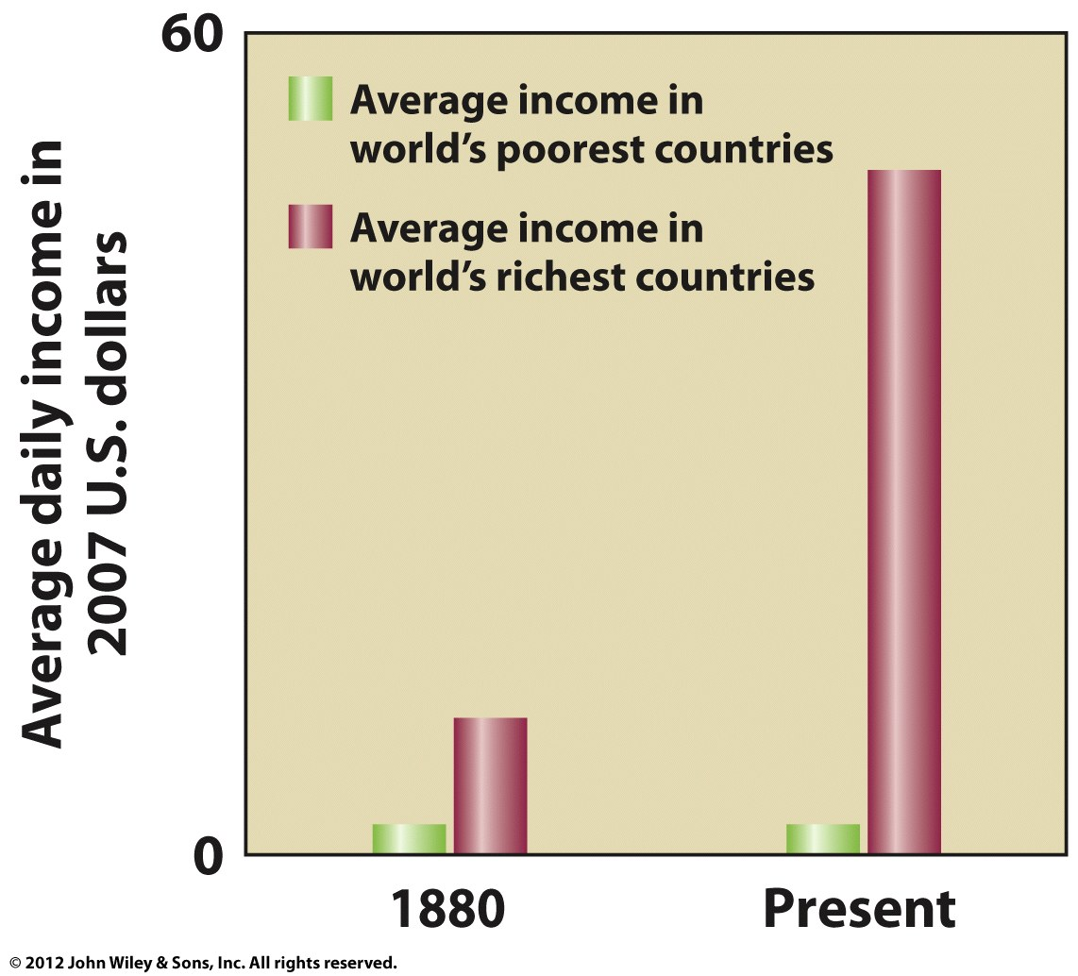

Wealth has increase significantly in developed countries and remained essential unchanged in developing countries.